1. Create a three dimensional array specifying float data type and print it.
Program
import numpy as np
arr=np.array([[[1, 2, 3], [4, 5, 6]], [[1, 2, 3], [4, 5, 6]]],dtype='f')
print(arr)
output
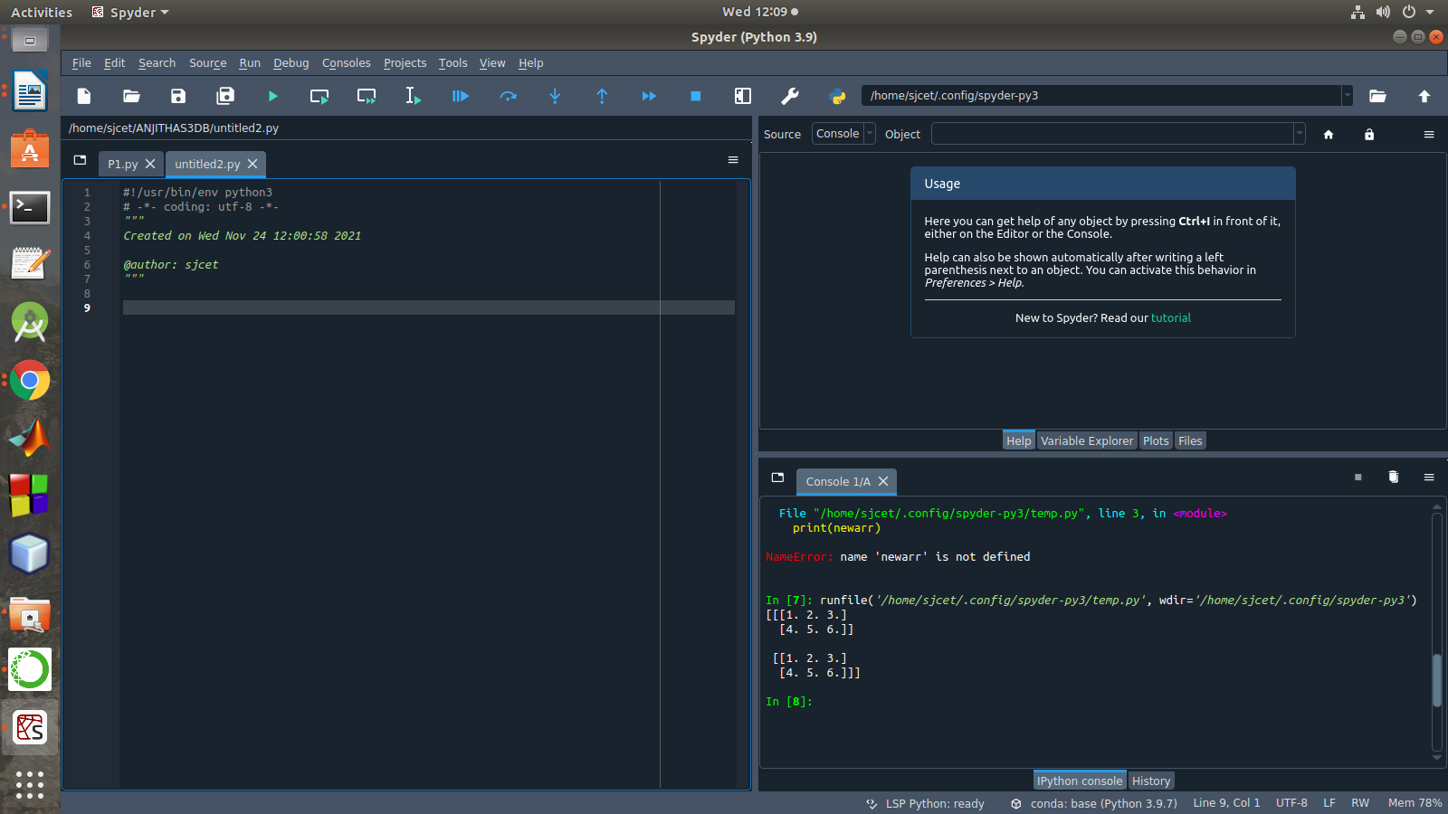

2. Create a 2 dimensional array (2X3) with elements belonging to complex data
type and print it. Also display
a. the no: of rows and columns
b. dimension of an array
c. reshape the same array to 3X2
program
import numpy as np
x = np.array([[2, 4, 6], [6.5, 8, 10]])
print(type(x))
print(x)
numOfRows = np. size(x, 0)
print(numOfRows)
numOfColumns = np. size(x, 1)
print(numOfColumns)
print("No. of dimensions: ", x.ndim)
rs=np.reshape(x, (3, 2))
print(rs)
output
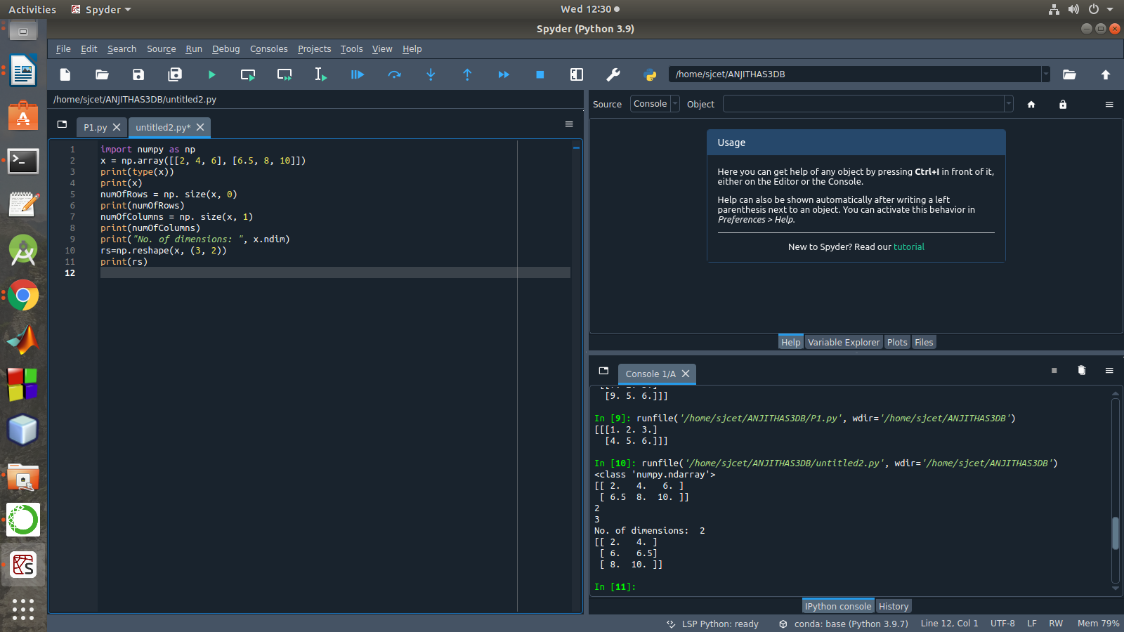

3. Familiarize with the functions to create
a) an uninitialized array
b) array with all elements as 1,
c) all elements as 0
program
import numpy as np
x=np.empty([2, 2])
print(x)
y=np.full((2, 2), 1)
print(y)
z=np.full((2, 2), 0)
print(z)
output

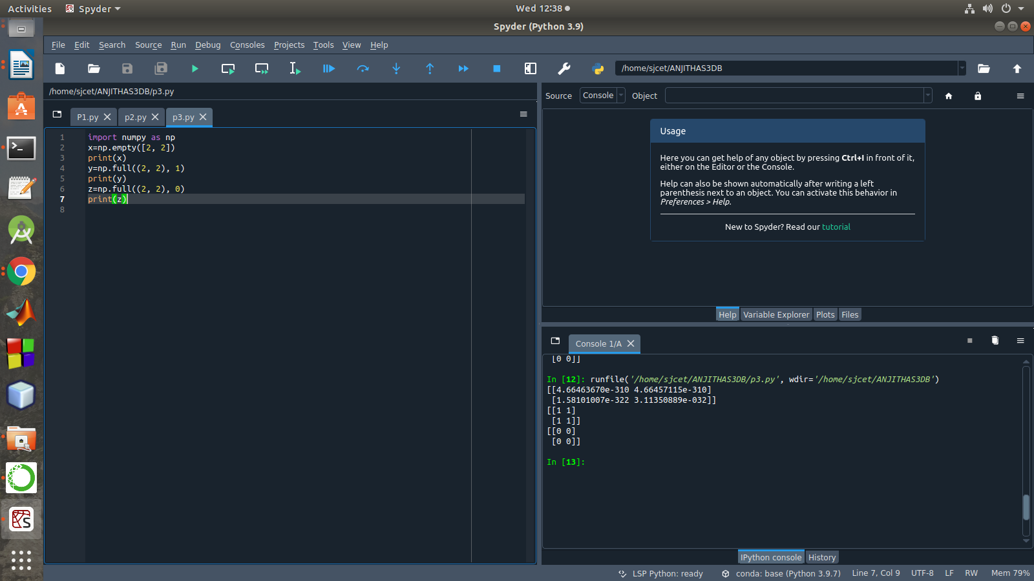

4. Create an one dimensional array using arange function containing 10 elements.
Display
a. First 4 elements
b. Last 6 elements
c. Elements from index 2 to 7
program
import numpy as np
a = np.arange(1, 11, 1)
print(a)
first_element = a[:4]
print(first_element)
first_element1 = a[5:]
print(first_element1)
first_element2 = a[1:7]
print(first_element2)
output

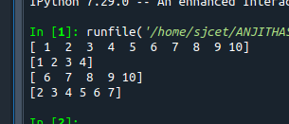

5. Create an 1D array with arange containing first 15 even numbers as elements
a. Elements from index 2 to 8 with step 2(also demonstrate the same
using slice function)
b. Last 3 elements of the array using negative index
c. Alternate elements of the array
d. Display the last 3 alternate elements
program
import numpy as np
a = np.arange(0, 15, 2)
print(a)
print("Elements from index 2 to 8 with step 2")
s2 = slice(2, 8, 2)
print(a[s2])
print("Last 3 elements of the array using negative index",a[-3:-1])
print("Alternate elements of the array")
ab = np.arange(1, 15, 2)
print(ab)
print("Display the last 3 alternate elements",a[-3:-1:2])
output
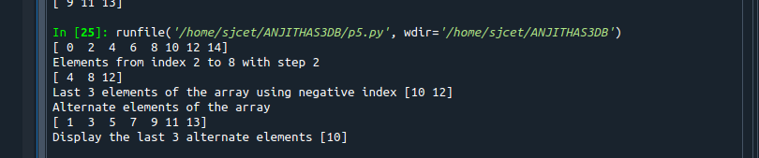

6. Create a 2 Dimensional array with 4 rows and 4 columns.
a. Display all elements excluding the first row
b. Display all elements excluding the last column
c. Display the elements of 1 st and 2 nd column in 2 nd and 3 rd row
d. Display the elements of 2 nd and 3 rd column
e. Display 2 nd and 3 rd element of 1 st row
program
import numpy as np
x = np.array([[2, 4, 6,1], [6, 8, 10,1],[1, 2, 1,1], [1, 1, 1,1]])
print(x)
print("Display all elements excluding the first row")
print(x[1:])
print("Display all elements excluding the last column")
print(x[:, :3])
print("Display the elements of 2 nd and 3 rd column")
print(x[:, 1:3])
print("Display the elements of 1 st and 2 nd column in 2 nd and 3 rd row")
print("Display 2 nd and 3 rd element of 1 st row")
print(x[0,1])
print(x[0,2])
output
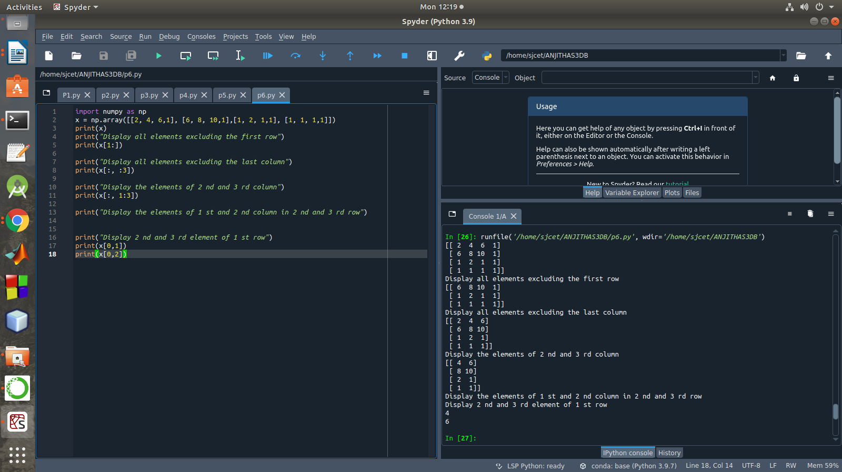

7. Create two 2D arrays using array object and
a. Add the 2 matrices and print it
b. Subtract 2 matrices
c. Multiply the individual elements of matrix
d. Divide the elements of the matrices
e. Perform matrix multiplication
f. Display transpose of the matrix
g. Sum of diagonal elements of a matrix
program
import numpy as np
M1 = np.array([[3, 6], [14, 21]])
M2 = np.array([[9, 27], [11, 22]])
M3 = M1 + M2
print("Matrix addition")
print(M3)
M1 = np.array([[3, 6], [14, 21]])
M2 = np.array([[9, 27], [11, 22]])
M3 = M1 - M2
print("Matrix Substract")
print(M3)
M1 = np.array([[3, 6], [14, 21]])
M2 = np.array([[9, 27], [11, 22]])
M3 = M1 / M2
print("Divide the elements of the matrices")
print(M3)
M1 = np.array([[3, 6], [5, -10]])
M2 = np.array([[9, -18], [11, 22]])
M3 = M1 * M2
print("Multiply the individual elements of matrix")
print(M3)
M1 = np.array([[3, 6], [5, -10]])
M2 = np.array([[9, -18], [11, 22]])
M3 = M1.dot(M2)
print("matrix multiplication")
print(M3)
M1 = np.array([[3, 6, 9], [5, -10, 15], [4,8,12]])
M2 = M1.transpose()
print("Transpose of the matrix")
print(M2)
M1 = np.array([[3, 6, 9], [5, -10, 15], [4,8,12]])
print("Sum of diagonal elements of a matrix")
print(np.trace(M1))

output
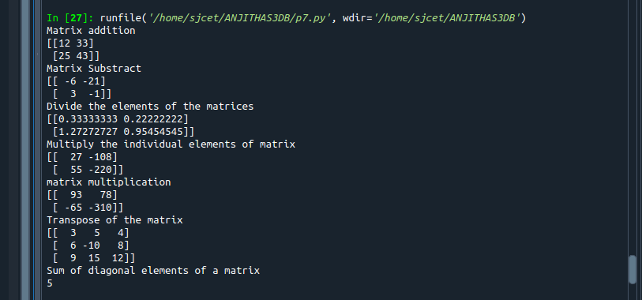

8.Demonstrate the use of insert() function in 1D and 2D array
program
import numpy as np
arr1 = np.arange(10, 16)
print("1D ARRAY ")
print("The array is: ", arr1)
obj = 2
value = 40
arr = np.insert(arr1, obj, value, axis=None)
print("After inserting the new array is: ")
print(arr)
print("Shape of the new array is : ", np.shape(arr))
print("2D ARRAY ")
arr1 = np.array([(1, 2, 3), (4, 5, 6), (7, 8, 9), (50, 51, 52)])
print("The array is: ")
print(arr1)
print("The shape of the array is: ", np.shape(arr1))
a = np.insert(arr1, 1, [[50], [100], ], axis=0)
print("New array is : ")
print(a)
print("Shape of the array is: ", np.shape(a))
output
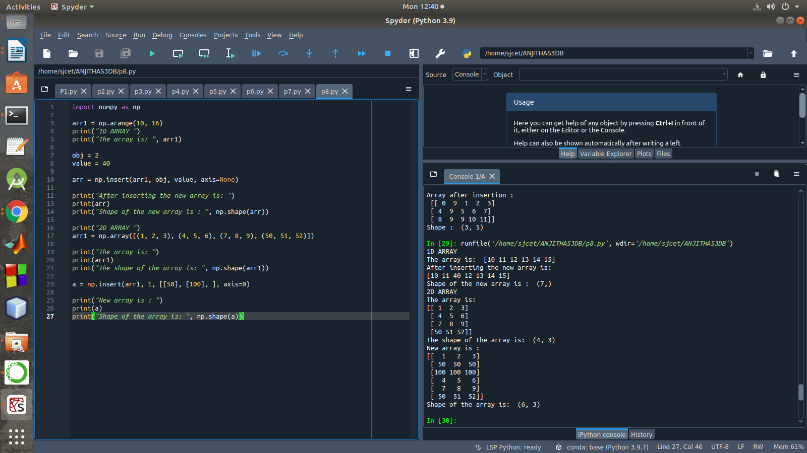

9. Demonstrate the use of diag() function in 1D and 2D array.
Program
import numpy as np

array_1d=np.arange(1,6).reshape((1,5))
print("1D array\n",array_1d)
print("use of diag() function in 1D array.")
x=np.diag(array_1d)
print(x,"\n")

array_2d=np.arange(9).reshape((3,3))
print("2D array\n",array_2d)
print("use of diag() function in 2D array.")
y=np.diag(array_2d)
print(y)

output
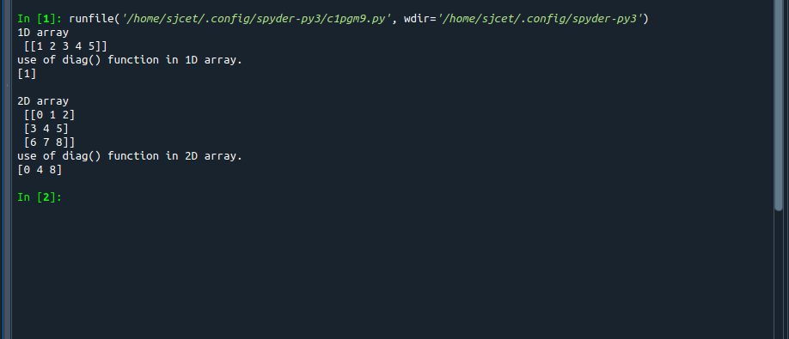
1

10. Demonstarte the use of append() function in 1D and 2D
array.
Program
import numpy as np

array_1d=np.array([1,2,3,4,5])
x=np.append(array_1d,6)
print("1D array",array_1d)
print("the use of append() function in 1D array",x)

array_2d=np.array([[1,2,3],[4,5,6]])
y=np.append(array_2d,np.array([[7,8,9]]),axis=0)
print("\n2D array")
print(array_2d)
print("the use of append() function in 2D array")
print(y)

output
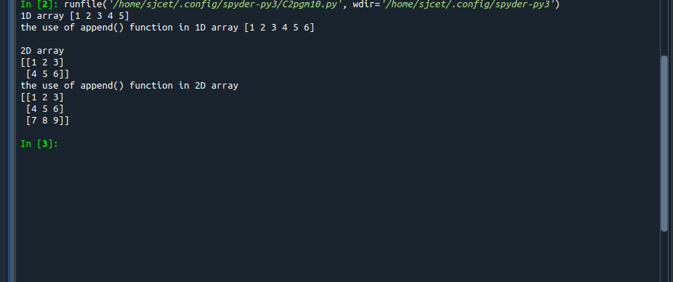

11. Demonstarte the use of sum() function in 1D and 2D array.
Program
import numpy as np

array_1d=np.array([1,2,3,4,5])
x=np.sum(array_1d)
print(array_1d)
print("the use of sum() function in 1D array",x)

array_2d=np.array([[[1,2,3],[4,5,6],[7,8,9]]])
y=np.sum(array_2d)
print("\n",array_2d)
print("the use of sum() function in 1D array",y)
output
